REPORT GUIDELINES
Page 1
COVER PAGE

Page 2
TABLE OF CONTENTS

Page 3
EXECUTIVE SUMMARY
- significant points of the report

Page 4 -?
REPORT BODY

- Results

- Conclusions

- Recommendations

- Acknowledgements

Last Pages
- Bibliography

Last Pages
- Appendixes

STUDENT COPY
Dahlberg A., Population ecology of Suillus variegatus in old Swedish Scots pine forests. Mycological Research 101 1997, pgs 47-54
Dahlberg A. & Stenlid J Size, distribution and biomass of genets in populations of Suiluus bovinus. Roussel revealed by somatic incompatibility New Phytologist, 1994, 128:225-234………………….

We found that up to 19 trees were linked together by the MNs. Of the 338 fungal tubercles collected, 338 were matched to both a tree and fungal type. See table 2.
55 of the 56 tree genotypes identified connected to a MN were linked to one or more trees. The maximum distance between any two trees within a network was 3 fungal links whether they were located farther from each other or closer or the size of the tree.……………..

This study was conducted in the cool, dry, interior Douglas-fir forest near Kamloops, Canada (51°51°’7’’N Lattitude, 120°31’46’’W Longitude). The plot was 1035 m above sea level, with a 10-40% slope. The plot we studied had 67 live trees. We grouped them into four age groups. We based their age on the stem diameter and the diameter of the whole group of trees. We sampled the below ground mychorrigal layer from four different sides of every tree in the plot where the canopy cover was sparse. We sampled fresh needles or bark from trees to gather the DNA samples.
Mathematically we modeled the location of the forest trees within the plot. We compared tree age, trees connected by the MNs. We modeled older trees connected to saplings, how close the clusters were, how many trees were connected together, …
Our Model was coded in NetLogo. We used a Network Small World Model as we viewed the Mychorrizal layer as a network. Agents were trees called nodes, the size of the node indicated tree age and the distance between trees was the Mychorrhizal network verified with forest data. We….

Architecture of the wood-wide web: Rhizopogon spp. genets link multiple Douglas-fir cohorts
New Mexico Supercomputing Challenge Final Report
April x, 2016

Team 25
Canadian High School
Team Members:
Kevin J, Beiler
Daniel M. Durall
Suzanne W. Simiard

The role of mycorrhizal networks in forest dynamics is poorly understood because of the elusiveness of their spatial structure. We mapped the underground distribution of the fungi Rhizopologon vesiculosus and Rhizopogon vinicolor and Douglas-fir trees to determine the architecture of a mycorrhizal network in a multi-aged old growth forest. We collected the mycorrhizas within a 30 x 30-meter plot. We identified them by DNA analysis and then matched them to above ground satellite image trees. We considered them linked if they shared the same fungus. The fungal network colonized approximately 19 trees in a plot. Multiple trees were linked with young saplings within the mycorrhizal network of Douglas-firs. We feel that if we represent trees as nodes and the Mychorrhizal Network as the connections, then a mathematical network model is appropriate. We found a strong relationship between tree size and connectivity, creating a robust network.

The architecture of our network suggests that MNs are a robust system where it would be protected from random changes, but would be affected if the hub trees (mature) were removed from the network. This poses a problem for forest management and clear cutting for logging. It appears that it is important to conserve large trees or groups of trees and the MNs. ………………………

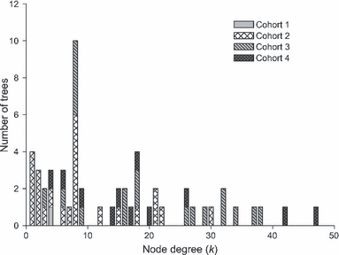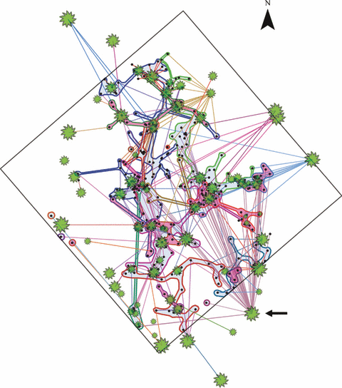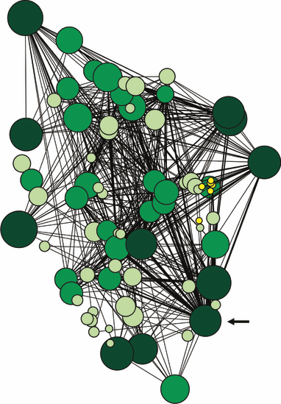

Summary …………………………………………Page 2
Description ……………………………………….Page 3-4
Results……………………………………………Page 5-7
Conclusions………………………………………Page 8-9
Bibliography………………………………………Page 10
Acknowledgements……………………………..Page 11
Appendices………………………………………Page 12-14

*information summarized, and excerpted from:
New Phytologist
Volume 185, Issue 2, pages 543-553, 29 OCT 2009 DOI: 10.1111/j.1469-8137.2009.03069.x
http://onlinelibrary.wiley.com/doi/10.1111/j.1469-8137.2009.03069.x/full#f2

EXAMPLE OF CORRECT VERSION FOR FINAL REPORT
Architecture of the wood-wide web: Rhizopogon spp. genets link multiple Douglas-fir cohorts
New Mexico Supercomputing Challenge Final Report
April x, 2017

Team 25
Canadian High School

Team Members:
Kevin J, Beiler
Daniel M. Durall
Suzanne W. Simiard

TABLE OF CONTENTS
Summary …………………………………………Page 2
Description ……………………………………….Page 3-4
Results……………………………………………Page 5-7
Conclusions………………………………………Page 8-9
Bibliography………………………………………Page 10
Acknowledgements……………………………..Page 11
Appendices………………………………………Page 12-14

SUMMARY
The role of mycorrhizal networks in forest dynamics is poorly understood because of the elusiveness of their spatial structure. We mapped the underground distribution of the fungi Rhizopologon vesiculosus and Rhizopogon vinicolor and Douglas-fir trees to determine the architecture of a mycorrhizal network in a multi-aged old growth forest. We collected the mycorrhizas within a 30 x 30-meter plot. We identified them by DNA analysis and then matched them to above ground satellite image trees. We considered them linked if they shared the same fungus. The fungal network colonized approximately 19 trees in a plot. Multiple trees were linked with young saplings within the mycorrhizal network of Douglas-firs. We feel that if we represent trees as nodes and the Mychorrhizal Network as the connections, then a mathematical network model is appropriate. We found a strong relationship between tree size and connectivity, creating a robust network.

DESCRIPTION
This study was conducted in the cool, dry, interior Douglas-fir forest near Kamloops, Canada (51°51°’7’’N Lattitude, 120°31’46’’W Longitude). The plot was 1035 m above sea level, with a 10-40% slope. The plot we studied had 67 live trees. We grouped them into four age groups. We based their age on the stem diameter and the diameter of the whole group of trees. We sampled the below ground mychorrigal layer from four different sides of every tree in the plot where the canopy cover was sparse. We sampled fresh needles or bark from trees to gather the DNA samples.
Mathematically we modeled the location of the forest trees within the plot. We compared tree age, trees connected by the MNs. We modeled older trees connected to saplings, how close the clusters were, how many trees were connected together, …
Our Model was coded in NetLogo. We used a Network Small World Model as we viewed the Mychorrizal layer as a network. Agents were trees called nodes, the size of the node indicated tree age and the distance between trees was the Mychorrhizal network verified with forest data. We….

RESULTS
We found that up to 19 trees were linked together by the MNs. Of the 338 fungal tubercles collected, 338 were matched to both a tree and fungal type. See table 2.
55 of the 56 tree genotypes identified connected to a MN were linked to one or more trees. The maximum distance between any two trees within a network was 3 fungal links whether they were located farther from each other or closer or the size of the tree. ……………..

CONCLUSIONS
The architecture of our network suggests that MNs are a robust system where it would be protected from random changes, but would be affected if the hub trees (mature) were removed from the network. This poses a problem for forest management and clear cutting for logging. It appears that it is important to conserve large trees or groups of trees and the MNs. ……………………….

BIBLIOGRAPHY
Dahlberg A., Population ecology of Suillus variegatus in old Swedish Scots pine forests. Mycological Research 101 1997, pgs 47-54
Dahlberg A. & Stenlid J Size, distribution and biomass of genets in populations of Suiluus bovinus. Roussel revealed by somatic incompatibility New Phytologist, 1994, 128:225-234………………….

APPENDICES
Diagram 1
Diagram 2 Diagram 3

*information summarized, and excerpted from:
New Phytologist
Volume 185, Issue 2, pages 543-553, 29 OCT 2009 DOI: 10.1111/j.1469-8137.2009.03069.x
http://onlinelibrary.wiley.com/doi/10.1111/j.1469-8137.2009.03069.x/full#f2

