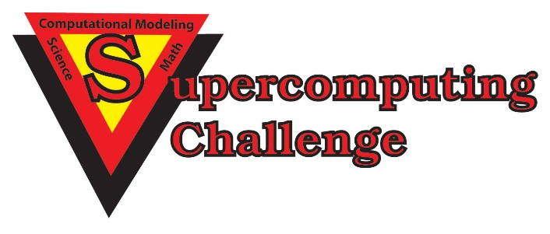

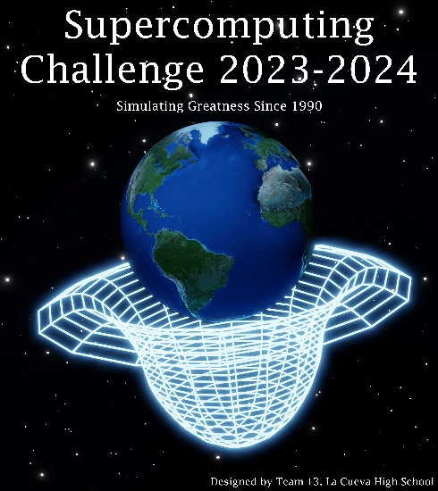

Schools that participated in the 2022-2023 Challenge
ATC, Capital, Cleveland, Cottonwood, Del Norte, Harrison Mid, Justice Code, La Cueva, Los Alamos High, McKinley Mid, Media Arts, Melrose, Monte Del Sol, NMSA, Sandia High, Sandia Prep, Santa Fe High, Santa Fe Prep, St. Thomas Aquinas, Taos, Truman Mid, Tucumcari

Get excited about Engineering, Math, Science, Computation and Innovation!
TAKE THE CHALLENGE!
WIN cash, scholarships, plaques and trophies!

CHOOSE your own computational science project and join students around
New Mexico for an exciting adventure this academic year!
Mentors are available all year to help you!
REGISTER in September at https://supercomputingchallenge.org
PLAN to attend the KICKOFF on Sept 30 - Oct 1 at NM Tech in Socorro.

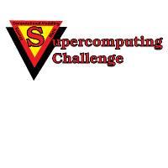

https://supercomputingchallenge.org consult@supercomputingchallenge.org

