Temporary Parking Permit
For Blue Parking Area


Issued by: Sharon Coble / Audra Tucker IM-2

Tenant Contact & Phone: Sharon Coble 663-5222 or Audra Tucker 663-5200

Event: Super Computing Challenge, Suite 201

Valid dates: April 21-22, 2003

Code for Week: W 10

- This Temporary LARP parking permit allows you to park in the blue striped area ONLY. If you park in any other colored area (yellow or green) or in the “1 Hour Visitor” spaces, you risk receiving a violation sticker. Automobiles receiving 2 violation stickers are subject to towing or booting.

- This permit is to be displayed on the dashboard of your vehicle.

- This temporary LARP parking permit is valid only during the date(s) listed above and must contain the correct code for the week.

- Please print temporary LARP parking permit in color, if possible. N
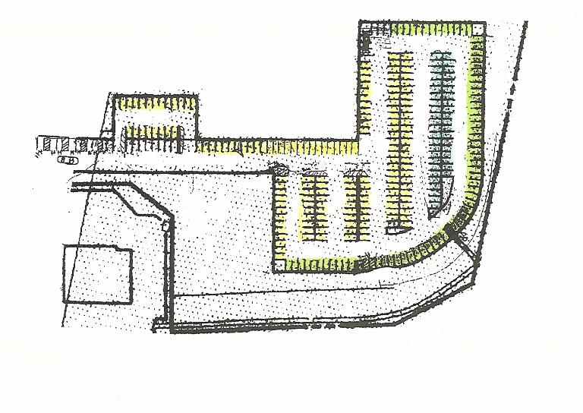
Los Alamos Research Park | Fire Station | Park in the blue striped area only

