NMSU

Special Topics Class, 501

Computational Science: Math Modeling and Problem Solving in Science

Supercomputing Challenge
2006
Summer Teacher Institute (STI)

Santa Fe Indian School July 16 - July 28, 2006

Syllabus

Mission Statement
The mission of the Supercomputing Challenge is to improve students' understanding and use of technology by developing their skills in scientific inquiry, modeling, computing, communication, and teamwork.

Summer Teacher Institute Description
The Summer Teacher Institute (STI) is a two-week institute for teachers offered by the Supercomputing Challenge in conjunction with Santa Fe Indian School, Los Alamos National Laboratory and New Mexico State University. Acquiring skills to support computational science applications for mid and high school students is the overarching goal of STI. Topics will include problem solving, science, mathematical and agent based modeling, technology, programming, research, working with mentors, project management, time management, team management, presentations, gender equity, computer ethics and technical writing.

Goal of STI
Teachers will learn how to sponsor a Supercomputing Challenge team and how to help students complete an appropriate computational science project. These important elements of a computational project will be covered and practiced: project definition and design, mathematical and agent based modeling, structured programming and design, timeline and milestone management, and application of Internet resources and tools. This year the Challenge is developing a unique program of middle school teachers.

Project Definition and Design
Project-based learning theory and practice will underscore the planning, research, development, refinement, and presentation of the computational models. Their own experiences in completing complex projects can give teachers a good understanding of the support that is key to successful implementations by their students. Challenge team teachers who have selected and narrowed interesting questions, written clear problem definitions, researched a topic, engaged a mentor, participated as a responsible teammate, written technical reports, made oral and computer presentations, and met deadlines will be well prepared to support fledgling teams. They will have learned about ethical research practice, experimented with team building strategies, learned both to recognize and address early warning signs of team dysfunction, had practice with the tools of the trade, and experienced first-hand the excitement of successful completion of a challenging project in a team environment.


Cathedral near the Santa Fe Plaza

Mathematical Modeling
Mathematical modeling is the process of creating a mathematical representation of some phenomenon in order to gain a better understanding of it; mathematical modeling is an integral component of the computational science project. During the process of building a mathematical model, the decisions are made about what factors are relevant to the problem and what factors can be de-emphasized. Once a model has been developed and used to answer questions, it should be critically examined and often modified to obtain a more accurate reflection of the phenomenon. In this way, mathematical modeling is an evolving process; as new insight is gained, the process begins again as additional factors are considered. Generally the success of a model depends on how easily it can be used and how accurately it predicts.

The mathematical modeling/computational science module will include an overview of the role of mathematical modeling in the computational science project, modeling sites and resources, some examples of models (compartmental models, population models, epidemic models, one- and two-dimensional heat flow models, etc.), and an introduction to some pitfalls in numerical computation. A major example will be drawn from epidemiology and implemented in Java, StarLogo and Mathematica. Spreadsheet examples will be referenced.

Structured Programming and Design

A. Introduction to Computer Programming – Java
Computer programming is the process of planning and creating a sequence of events for a computer to follow. In this unit we will utilize Java for PCs running Windows or on a Linux machine.

Java is a full-featured programming language similar in functionality to C++
and other high-level languages. Once heralded as "the next big thing" for
the web, Java is now regarded as a very capable language for creating
stand-alone applications as well; this is partly due to the relative ease
with which a Java programmer can create a graphical user interface. Many
colleges and universities use Java in their introductory courses in computer
programming, and the College Board AP (Advanced Placement) Computer Science test uses Java.

- Introduction to StarLogo

The StarLogo language was designed to enable people to build their own models of complex, dynamic systems. Unlike many other modeling tools, StarLogo supports a tangible process of building, analyzing, and describing models that do not require advanced mathematical or programming skills. Using StarLogo, one can build and explore models and in the process develop a deeper understanding of patterns and processes in the world. In StarLogo, one writes simple rules for individual behaviors. For instance, one might create rules for a bird, which describe how fast it should fly and when it should fly towards another bird. When one watches many birds simultaneously following those rules, she can observe how patterns in the system, like flocking, arise out of the individual behaviors. Building up models from the individual, or "bird," level develops a better understanding of the system, or "flock," level behaviors.
Santa Fe Sunset

C. Mathematica
From simple calculator operations to large-scale programming and interactive-document preparation, Mathematica is a tool at the frontiers of scientific research, engineering analysis and modeling, technical education from high school to graduate school, and wherever quantitative methods are used.

D. Analysis and Forecasting with Spreadsheets
Spreadsheets offer the function of predicting a trend from some existing data. Once you are happy with the reliability of the data you have sourced, you can find out what would be the outcome for a dependent variable in the event of the independent variable (usually time) moving in steps. Linear regression is a statistical technique that is often used in business.
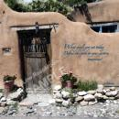
Santa Fe Entryway

Internet Resources – The Challenge website, http://challenge.nm.org, will link to all important resources: Technical Guide, teacher resources on gender equity, ethics, computational science, mentors, research, presentations, technical writing, grants, programming, data resources, etc. Links to science, math, technology and computational science standards and ways to integrate technology into the curriculum will be utilized. These sites will be shared throughout the two weeks. Additionally, the class will use threaded discussions, forums and other tools to enhance communication among team members and between course participants and staff.

Course Requirements
Students will attend two full weeks of classes, 60 hours, covering core components of computational science: project definition, modeling, programming, and examples of results of different scenarios.

Students will
- participate in creating a team supercomputing computational project
- present the project to a team of judges
- learn about the 2006-07 Challenge timetable, milestones and expectations
- learn programming skills: an introduction to JAVA programming, StarLogo, Mathematica and Excel programming
- learn how to make mathematical and agent based models, apply computational techniques, project management tips, and research aides.
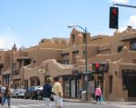

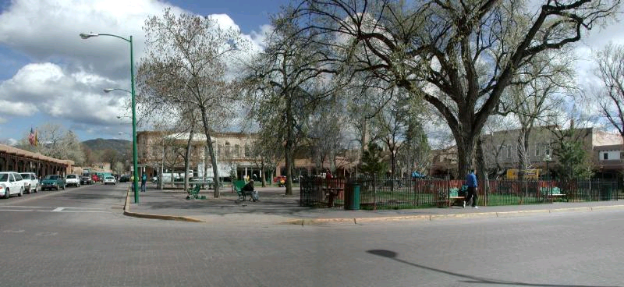

Santa Fe Plaza

Credit
Interested attendees will receive three units of graduate credit from New Mexico State University, Special Topics Class 501, “Computational Science: Math Modeling and Problem Solving in Science.”

Grading
Grading will reflect the development of a computational science project. Enrollees are expected to participate fully in discussions, activities related to topics, and to share their implementation plans for school year 2006-2007.

Readings and Online Resources and Software
Readings are in the STI library or online. Technical manuals will be accessed from online sources. The library will have books from the instructors’ collections of texts and references that relate to computational science, modeling, complex systems and personal favorites.

National Geographic Special: Guns, Germs & Steel (DVD)

NetBeans - NetBeans is an integrated development environment (IDE), developed and made available at no cost by Sun. It is principally for use in Java development, but can also be used for writing code in other languages.
www.netbeans.org/

Mathematica Student Resources
http://www.wolfram.com/products/student/mathforstudents/resources.html

G. Polya "How to Solve It: A New Aspect of Mathematical Method"
Online summary: http://www.math.utah.edu/~pa/math/polya.html

Towards 2020 Science — A Reader’s Guide, March 2006, Microsoft
Schools Fail to Teach and 2020 Science Report Summary

Use of Complexity Science
http://complexsys.org/pdf/ComplexityScienceSurvey.pdf

US Efforts May Not Slow Spread of Flu
http://www.nytimes.com/aponline/us/AP-Preventing-Pandemic.html?_r=1&oref=slogin

The Landscape of a Pandemic
http://www.chron.com/disp/story.mpl/front/3823093.html

The Challenger: An Information Disaster
http://www.asktog.com/books/challengerExerpt.html
Lessons for data analysts from the Challenger disaster
http://www.statview.com/support/techsup/faq/Tufte/tufte.shtml

Supercomputing Challenge web page resources
http://challenge.nm.org/resources

Guiding Student Research: Making Research Happen in Your School: The National Consortium for Specialized Secondary Schools of Mathematics, Science and Technology

StarLogo Download from http://education.mit.edu/starlogo

phpbb – Creating Communities
Teacher Forum

Skype Voice over IP

Other Resources
Hands On! Newsletter on math and science learning - TERC http://www.terc.edu/
Teaching Tolerance Magazine from the Southern Poverty Law Center –http://teachingtolerance.org/
T.H.E Journal (Technological Horizons in Education) – Professional Development, Distance Learning, Curriculum – http://www.thejournal.com/
The Magazine of Design & Technology Education, ties – Resources, Multimedia, Literature – good ideas for projects - http://www.tiesmagazine.org/
New Mexico Science List Serv -Subscribe at http://monty.manzano.aps.edu/mailman/listinfo/science

Bad Science

http://www.ems.psu.edu/~fraser/BadScience.html

Gender Equity

http://www.holtsoft.com/chris/CASCONEquity.pdf

Women in Science

http://www.womeninscience.org/

Girls are Closing the Gap

http://www.nctm.org/news/ext_articles/2004_0105_girls.htm

Mathematical Models

http://www.krellinst.org/AiS/textbook/unit2/projdev2.3.5.html

Modeling for Understanding in Science Education

http://www.wcer.wisc.edu/ncisla/muse/

NASA Math Models and Data - http://geo.arc.nasa.gov/sge/landsat/l7.html

Non-software Teacher Resources to Support Modeling

http://www.ecsu.k12.mn.us/envision/gradrule/additional.html

Siemens Westinghouse Competition
http://www.siemens-foundation.org/


Santa Fe Opera

Instructors
Nick Bennett, Grass Roots Consulting, nickbenn@g-r-c.com
Celia Einhorn, Supercomputing Challenge, celia@pobox.com
Gina Fisk, Los Alamos National Laboratory, gina@lanl.gov
Betsy Frederick, Supercomputing Challenge, bfrederick@zianet.com
Dale Henderson, Nuestros Valores Charter School, daleh@unm.edu
David Kratzer, Los Alamos National Laboratory, dhk@lanl.gov
Irene Lee, Santa Fe Institute / MIT ITEST Program, lee@elf.org
Dr. Hal Scheintaub, The Governor’s Academy, MIT, hscheintaub@gda.org
Dr. Willard Smith, Tennessee State University, smith@coe.tsuniv.edu
James Taylor, Santa Fe Preparatory School, jtaylor@santafeprep.org

Schedule for 16 July – 28 July
Schedule for 16 July – 28 July Summer Teacher Institute

Sunday, 16 July. 5:00 – 8:30
Dormitory Check In
Reception, Introductions
Icebreakers

Monday-Friday, 17 July – 21 July, 8:30 – 4:30

The first week of Summer 2006 STI is devoted to learning what a successful computational project is. We will use an epidemiologic example and develop models in Java, StarLogo, and Mathematica. All participants will be introduced to each of the software tools. By Wednesday, they will have selected one to use to develop a well-defined example that will be presented on Friday.

Participants will use the Challenge tools (phpbb forum, listserv, Challenge Web Page resources, Skype) as a routine part of reporting, discussion, research and assessment.

On Monday the 17th, Hal Scheintaub will make a Keynote Presentation. Other special events including visits with summer lecturers at Santa Fe Institute will round out the week.

Monday – Friday, 24 July – 28 July

During the second week, students will draw on the experiences with the epidemiology models and plan and execute their own projects in team format. The effort will incorporate the essential practices that their students will need to complete a successful Challenge project: problem definition, abstracts, research, mentors, good teamwork strategies, milestone planning, programming, multiple examples, and oral, visual, and written presentations. Lecture/online tutorials will address each of these aspects. The projects will be shown to a panel of Challenge judges on Friday afternoon.

The second week will include a detailed look at the Challenge year schedule with an emphasis on deadlines and special events. Additionally, students will continue to explore and utilize the resources available at http://challenge.nm.org. Visiting scientists, Challenge teams and teachers from previous years, video presentations, and internet resources will continue to supplement the project work. Additionally, there will be continued use of the bulletin boards, eMail, and video/audio tools for discussion, reflection and assessment.

Suggested Evening and Weekend Field Trips

Visit Santa Fe!

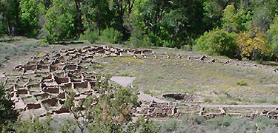
A Hike in Bandelier

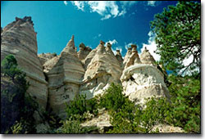

Tent Rocks - Another Hike



Museums

Santa Fe Chamber Music Schedule

Tesuque Flea Market Fri., Sat. and Sun: 8AM — 4PM

July 14 Cochiti Pueblo Feast Day

July 15-16 36th Northern Pueblo Artist and Craftsman Show

July 25-26 San Ildefonso and Taos Pueblos: Santiago's and Santa Ana Day Dances

