$90,000 in Scholarships
will be awarded to several outstanding students from New Mexico
in April 2008 for their work in the
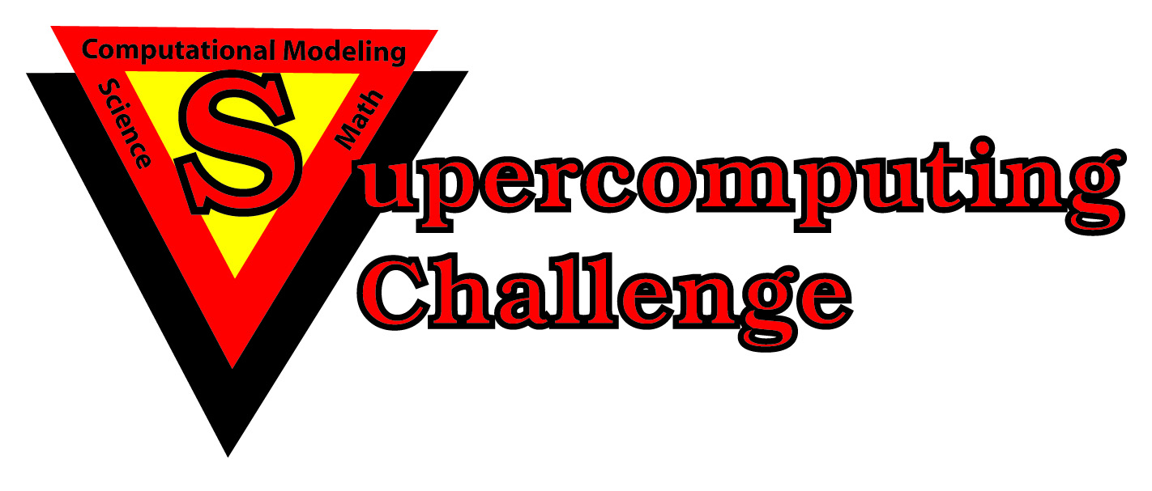
Teams of one to five students will conduct
independent scientific research
on topics of their own choosing.

Guided by mentors
from the National Laboratories, State Universities, and private businesses,
students will learn important skills to give them an edge in their college classes.

These important research skills are not usually taught in advanced placement classes!

How can students in your school district
compete for these valuable scholarships?

Encourage a teacher to attend our Summer Teacher Institute professional development seminar, then next year they can sponsor one or more teams!

We pay teachers to attend the seminar!

The Supercomputing Challenge will pay teachers $500 for successfully completing our intensive two-week seminar; it will be held July 8-20, 2007 at Central New Mexico Community College in Albuquerque.

Teachers may earn three graduate credit hours from New Mexico State University.
We pay the tuition!
We provide the books!
We pay room and board!

To learn more contact:
Betsy Frederick Celia Einhorn
Phone: (505) 220-5050 Phone: (505) 281-1122
E-mail: sticore@challenge.nm.org http://challenge.nm.org/sti

HURRY! CLASS SIZE IS LIMITED!
Sponsored by Los Alamos and Sandia National Laboratories,
the NM State Legislature and the Public Education Department

