
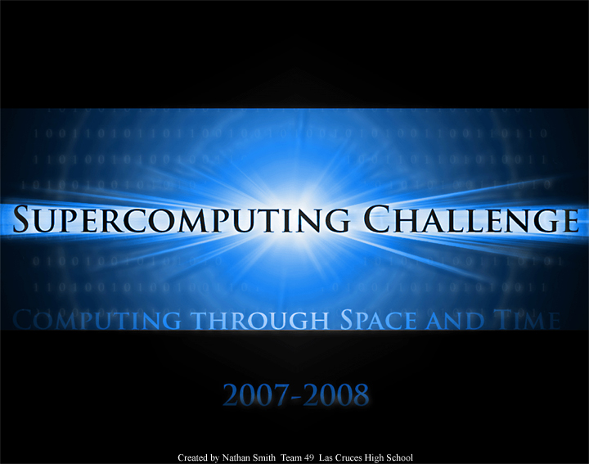

Meet the Scientist Session
Glorieta Kickoff – 2007

To be filled out by team members based on the advice from the scientist and given to your teacher sponsor.

Team Number

Team Members

Project Title

Computational or Agent-based Aspect:

Suggested Language or Software Tool:

What is the data to be collected?

How will the data be visualized?

Modifications from Scientist:

_____The proposal for the above named project has been accepted as a computational science project for the 2007 – 2008 Challenge year.

Scientist's Signature ____________________________________________

Date_________________________________

