Fast Fourier Transform (FFT) Exercise in Excel
The FFT is effective at identifying repetitive patterns in the data that are functions of periodic waveforms such as sine and cosine waves. The patterns are functions of frequency or period, which is the inverse of frequency. The period is the distance between peaks in the data. In the Hare/Lynx data, a regular periodic pattern is clearly apparent in the data. We want to determine what the periodic frequency is in the data. This is often expressed in species population as an “x” year cycle and we want to find out what is the value of x. We can roughly calculate the period by counting the peaks, 9 or 10, and divide by the number of years sampled, 91. So the period is roughly 9 or 10 years. Let’s see how to calculate it more accurately and look for other cyclical patterns.
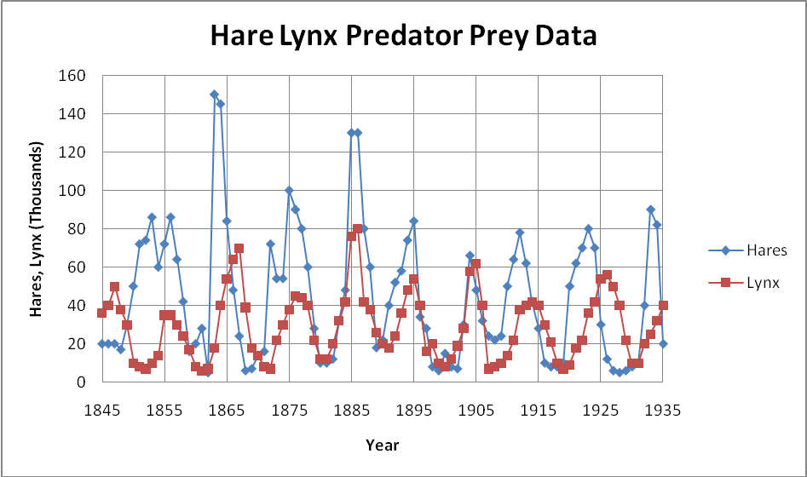
First check to see if Excel has the Data Analysis ToolPak installed. Pull down the Tools menu and see if Data Analysis is an option on the menu. If not, go to the Tools menu and click on Add-Ins. Select the Analysis ToolPak for installation. You may need your original Office CD-Rom to install the ToolPak. In the latest Office, the installation is a bit different. Select the big Office button in the upper left corner of the Excel window and select Excel Options at the bottom of the menu. Select Add-Ins and the find the Analysis ToolPack for installation.
1. Import the Hare/Lynx data into the Excel Spreadsheet. This is done by selecting the Data menu and then Get External Data. Select From Text and then change the filter from text files to all files. Select the hare-lynx.dat file with the Hare/Lynx data. Select Delimited and click on Next. Select Tab and click on Next. Select General column data format and click on Finish. Click on the A2 box for where you want to put the data and click on OK. Label the columns Date, Hares, Lynx.
2. Now setup the data for the FFT. The FFT in Excel can only operation on powers of 2 (2^{n}). We have 91 data points which is between 64 (2⁶) and 128 (2⁷), the closest powers of two. We could just use the first 64 data points, but one of the tricks in data sets that are not exactly powers of 2 is that you can just add zeros to fill in the data to make the series a power of 2. So add zeros in columns A, B, and C from row 93 to 129 (add 1 extra to account for the header). Then label the D column header Hare FFT Complex and the E column header, Lynx FFT Complex and make the columns wider.
3. Run the FFT on column B. Select Tools->Data Analysis->Fourier Analysis (Data->Data Analysis->Fourier Analysis in the latest Excel). Set the input data range to B2:B129 and the output to D2:D129. Repeat for column C and put the output data in column E. The output is in complex format with both a real and imaginary components.
4. Now we want the magnitude of the FFT instead of the complex value. We will put these results in columns H and I, so label column H, Hare FFT Magnitude and column I, Lynx FFT Magnitude. First we need to multiple the result by 2/number of samples (n_{s}). In this case, n_{s} is 128. We use the Excel intrinsic IMABS to get the magnitude of the complex number (note: this is the sqrt(real²+imag²) in vector arithmetic). So in H2, enter the formula “=2/128*IMABS(D2)”. Copy this formula to H128 and over to column I.
5. Now we need to calculate the x axis values so we can plot the results. First we label column F, FFT Frequency. The first frequency is always zero, so we put zero in F2. What this means is that the first value in the FFT is the average value for the data. So 62.9 is the average number of hares and 41 is the average number of Lynx. Then to calculate the frequency, we use the formula F_{s}/n_{s} where F_{s} is the sampling frequency, roughly 1 sample per year in this case and n_{s} is the number of samples or 128 in this example. So cell F3 is 1x1/128, cell F4 would be 2x1/128 and so on. We can enter the series by selecting Edit->Fill->Series (In the more recent Excel, select Home-> (in Editing)->Series) while in cell F2. Select column and enter 1/128 or .0078125 for the step value and 1 for the stop value.

6. To fill in the period column, first label column G, FFT Period. In G3 enter “=1/F3”. Copy this formula down through row 129.

7. Plotting the data. Select columns G, H, and I by clicking on the G, H, and I (hold down the control key while selecting the additional columns). Now insert a chart->scatter plot. Edit the data source to include only through row 66. If you look at the values in H65 and H67 and I65 and I67, you will note that the data repeats and it repeats for all the values after row 66. This is a characteristic of FFTs and is why you should only plot half of the data. Format the plot to look something like this below:

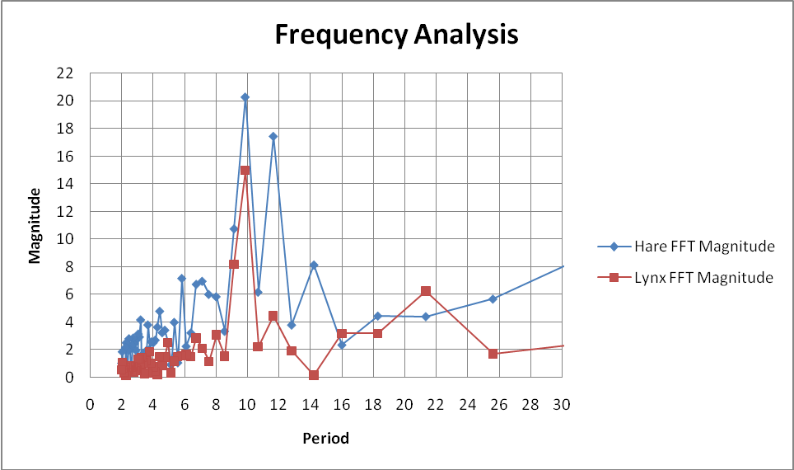

From this plot, we can see that the dominate period for the lynx data is a 10 year cycle. The Hare data also shows a 10 year cycle, but there are secondary peaks nearly as large for 12 year and 14 year cycles.

