

Schools that participated in the 2017-2018 Challenge

ATC, Atrisco Heritage, Barranca Mesa, Capital, Century, Eldorado, Freedom, Gadsden, Jackson, Los Alamos, Los Lunas, McCurdy, Melrose, Mesa Mid, Mesa View, Monte Del Sol, New Futures, NMSA, NexGen, Pinon, Portales, Rio Abajo, Rio Rancho Cyber, Ruidoso Mid, San Juan, Sandia Prep, Santa Fe, Santa Teresa Mid, Saturday Sci & Math Acad., South Valley, Taos, Upward Bound M&S, YWiC

Get excited about Engineering, Math, Science, Computation and Innovation!
TAKE THE CHALLENGE!
WIN cash, scholarships, plaques and trophies!

CHOOSE your own computational science project and join students around
New Mexico for an exciting adventure this academic year!
Mentors are available to help you!
REGISTER between September 1-20 at https://supercomputingchallenge.org
PLAN to attend the KICKOFF at New Mexico Tech October 13-14
To participate in the 29th Annual Supercomputing Challenge, see:

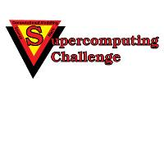

https://www.supercomputingchallenge.org consult@supercomputingchallenge.org

