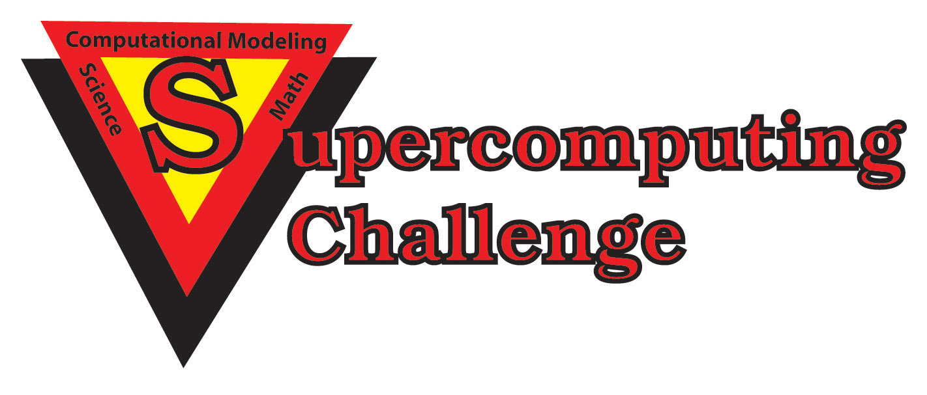

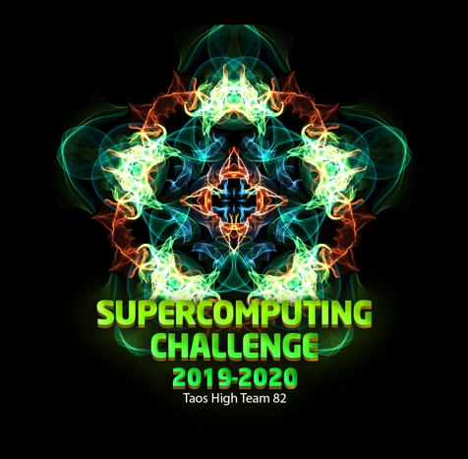
Schools that participated in the 2018-2019 Challenge
ATC, Alb High, Barranca Mesa, Capital, Chaparral, Cleveland MS, Cottonwood, Eldorado, Gadsden, Jackson MS, La Cueva, Las Cruces, Los Alamos, Los Lunas, Manzano, Mayfield, Media Arts, Melrose, Mesilla Valley, Monte Del Sol, NMSA, NexGen, Portales, Rio Rancho Cyber, Robertson, San Jon, Sandia, Santa Fe, Sarracino Mid, SODA., Shiprock, Socorro, Taos, Technology Leadership High, Upward Bound M&S

Get excited about Engineering, Math, Science, Computation and Innovation!
TAKE THE CHALLENGE!
WIN cash, scholarships, plaques and trophies!

CHOOSE your own computational science project and join students around
New Mexico for an exciting adventure this academic year!
Mentors are available all year to help you!
REGISTER between September 1-20 at https://supercomputingchallenge.org
PLAN to attend the KICKOFF at New Mexico Tech October 12-13

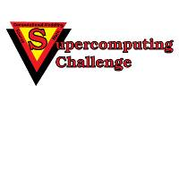

https://www.supercomputingchallenge.org consult@supercomputingchallenge.org

