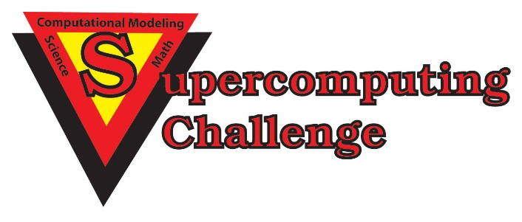

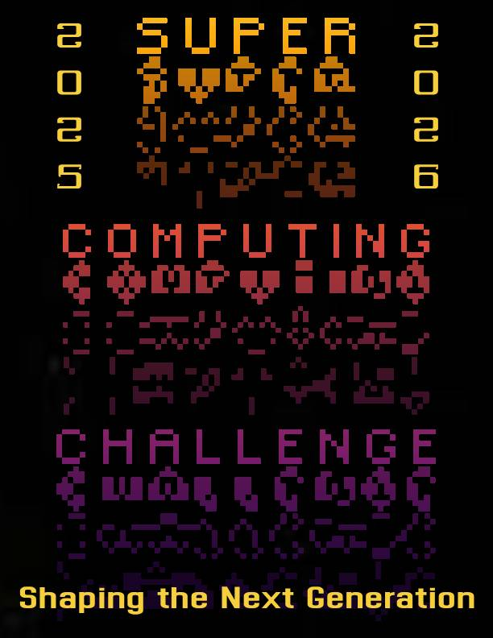

***Schools that participated in the 2024-2025 Challenge***

***Alb Academy, Capital, Elorado, Harrison Mid, Justice Code, La Cueva, Los Alamos High, Los Alamos Mid, Melrose High, Melrose Mid, Mountain Elem, New Futures, NM Acad for Media Arts, NMSA, Santa Fe Prep,***

***St. Thomas Aquinas, Truman Mid***

**Get excited about Engineering, Math, Science, Computation and Innovation!**

***TAKE THE CHALLENGE!***

**WIN cash, scholarships, plaques and trophies!**

**CHOOSE your own computational science project and join students around**

**New Mexico for an exciting adventure this academic year!**

**Mentors are available all year to help you!**

**REGISTER in September at** [**https://supercomputingchallenge.org**](https://supercomputingchallenge.org)

**PLAN to attend the KICKOFF on Oct 11-12 at NM Tech in Socorro.**

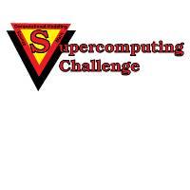

[**https://supercomputingchallenge.org**](https://supercomputingchallenge.org)[**consult@supercomputingchallenge.org**](mailto:consult@supercomputingchallenge.org)