

2026-27 Team Form and Scientist Interview

To be filled out by team members based on the advice from the scientist and given to your teacher sponsor. Please make a copy for each team member.

General Information
A computer model is a representation of a real-life system or situation, such as the workings of an epidemic, or the evacuation of a football stadium.

Names and Grade Levels of the Team Members

Captain’s name and email address

Teacher Sponsor

Title of your Project

Model Information
What is the question your model will answer? If it is a question that you already know the answer to, you need to choose a new question.

What computer modeling language have you decided to use?

In computational modeling, a collection of rules is created to study what would happen in real-life situations. Changes are made to see how they affect the outcome.
A computational model contains numerous variables that represent your problem. What variables or changes will you manipulate?

How will you show your data? What visualization tools will you use? (Images, graphs, tables, charts, scatterplots, time, space, relationships?)

How will you Identify potential resources – on-line and off-line knowledge? The Final Report will need citations for these resources. Staff suggests Citation Machine. Check with your school librarian for assistance.

Focus of the Problem
How will you be able to show progress in seven months? Do you need to simplify your project? Do you need to focus your project?

Are you doing any sensitive or private experimentation to collect data on humans or animals? If so, please let Consult, <consult@supercomputingchallenge.org> know.

Scientist Info
Modifications to the project

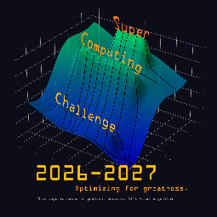
Organization Date of Interview Signature of Scientist

Thank you for your time and interest. May this be the best Challenge year ever.

