2007-2008
Supercomputing Challenge
2006-2007 Finalists
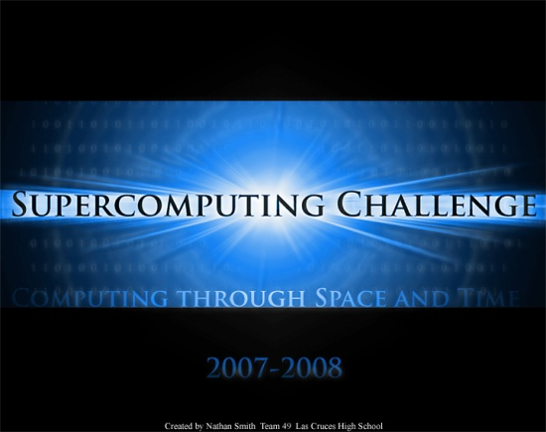
Albuquerque
Academy

Eldorado
High School

Homeschool

Las Cruces
High School

Los Alamos
High School

Manzano
High School

Oñate
High School

Sandia
Preparatory
School

St. Pius X
High School

Get excited about Math, Science and Technology!

TAKE THE CHALLENGE!

Winners receive computer equipment, scholarships, savings bonds, plaques and trophies.

Choose your own computational science project and join students around New Mexico for an exciting adventure this academic year!

To participate in the 18th Annual Supercomputing Challenge, see:

http://www.challenge.nm.org consult@challenge.nm.org

