2008-2009
Supercomputing Challenge
Schools that participated in the 2007-2008 Challenge
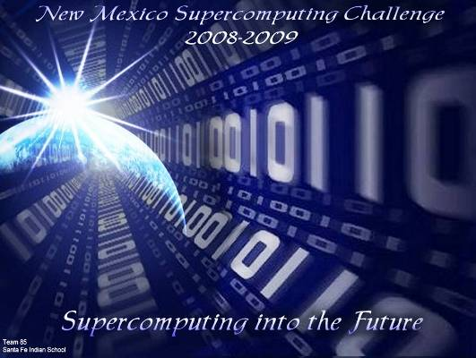
ATC, Alamogordo,
Albuquerque Academy,
Artesia, Aspen, Barranca,
Belen Mid, Bloomfield,
Bosque School, Capshaw,
Chaparral, Espanola, Farmington, Freedom,
Jackson, La Cueva,
Las Cruces, Los Alamos,
Los Alamos Mid, Manzano,
McCurdy, Melrose,
Monte del Sol,
Navajo Prep, Rio Rancho,
Rio Rancho Mid-High,
Sandia Prep,
Santa Fe Indian School,
Shiprock, Socorro,
St. Pius X, Taylor Mid

Get excited about Engineering, Math, Science and Technology!

TAKE THE CHALLENGE!

Winners receive computer equipment, scholarships, savings bonds, plaques and trophies.

Choose your own computational science project and join students around New Mexico for an exciting adventure this academic year!

To participate in the 19th Annual Supercomputing Challenge, see:

http://www.challenge.nm.org consult@challenge.nm.org

