2010-2011
Supercomputing Challenge
Schools that participated in the 2009-2010 Challenge

AIMS@UNM, Alamogordo
Albuquerque Academy, Albuquerque High,
Artesia, Aspen, ATC, Barranca, Bloomfield, Bosque School, Capshaw, CEPi1, Chaparral, Deming, Desert Academy, Edgewood, Espanola, Freedom, Hatch, Hope Christian, Jackson, Lincoln,
Los Alamos High, Los Alamos Mid, Manzano,
McCurdy, Media Arts, Melrose, Monte del Sol, Moriarty, Navajo Prep, NNMC, Nuestros Valores,
Penasco, Quemado, Red Mountain, Rio Rancho, San Jon, Sandia Prep, Santa Fe, Santa Fe Indian School, Santa Fe Prep, Silver, Socorro, Tibbetts

Get excited about Engineering, Math, Science, Technology and Innovation!

TAKE THE CHALLENGE!

Winners receive cash, scholarships, computer equipment,
plaques and trophies.

Choose your own computational science project and join students around New Mexico for an exciting adventure this academic year!

To participate in the 21st Annual Supercomputing Challenge, see:

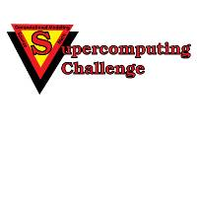
http://www.challenge.nm.org consult@challenge.nm.org

