2011-2012

Supercomputing Challenge
Schools that participated in
the 2010-2011 Challenge
AIMS@UNM, Alamogordo
Albuquerque Academy, Aldo Leopold High,
Annunciation Catholic,
Artesia, Aspen, ATC, Bernalillo, Bloomfield, Capshaw, CEPi1, Chaparral, Cleveland, Deming, Desert Academy, Edgewood, Espanola, Freedom, Hatch, Jackson, La Cueva, Las Cruces,
Las Montanas
Los Alamos High, Los Alamos Mid, Manzano,
Mayfield, McCurdy, Melrose, Monte del Sol, Moriarty, Navajo Prep, Nex+Gen Academy,
Onate, Penasco, Quemado, Red Mountain, Rio Gallinas, Roberson, Sandia Prep, Santa Fe, Saturday Sci&Math Acad, Silver, St. Michaels, The MASTERS Program, Volcano Vista

Get excited about Engineering, Math, Science, Computation and Innovation!
TAKE THE CHALLENGE!
Winners receive cash, scholarships, computer equipment,
plaques and trophies.

Choose your own computational science project and join students around
New Mexico for an exciting adventure this academic year!
To participate in the 22nd Annual Supercomputing Challenge, see:

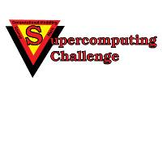
http://supercomputingchallenge.org consult@supercomputingchallenge.org

