2014-2015
Supercomputing Challenge
Schools that participated in the 2013-2014 Challenge
ATC, AIMS@UNM,
Albuquerque Acad,
Annunciation Catholic,
Aspen, Capital, Centennial, Chaparral, Cottonwood Valley, Deming, Desert Academy, Down to Earth, Edgewood, Jackson,
La Cueva, Las Cruces,
Los Alamos, Los Lunas, Manzano, Melrose, Mesa,
Miyamura, Moriarty, Mountain, NM School for the Arts, Newcomb, Picacho, Quemado, Red Mountain, Rio Rancho Cyber Acad, Santa Fe High, Saturday Sci & Math Acad, School of Dreams Acad, Socorro, St. Pius X, Taos, The MASTERS Program, White Sands

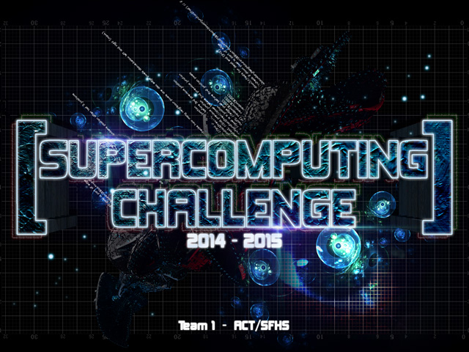

Get excited about Engineering, Math, Science, Computation and Innovation!
TAKE THE CHALLENGE!
WIN cash, scholarships, plaques and trophies!

CHOOSE your own computational science project and join students around
New Mexico for an exciting adventure this academic year!
Mentors are available to help you!
REGISTER between September 1-20 at http://supercomputingchallenge.org
PLAN to attend the KICKOFF at New Mexico Tech October 11-12
To participate in the 25th Annual Supercomputing Challenge, see:

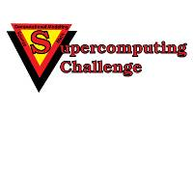

http://www.supercomputingchallenge.org consult1415@supercomputingchallenge.org

